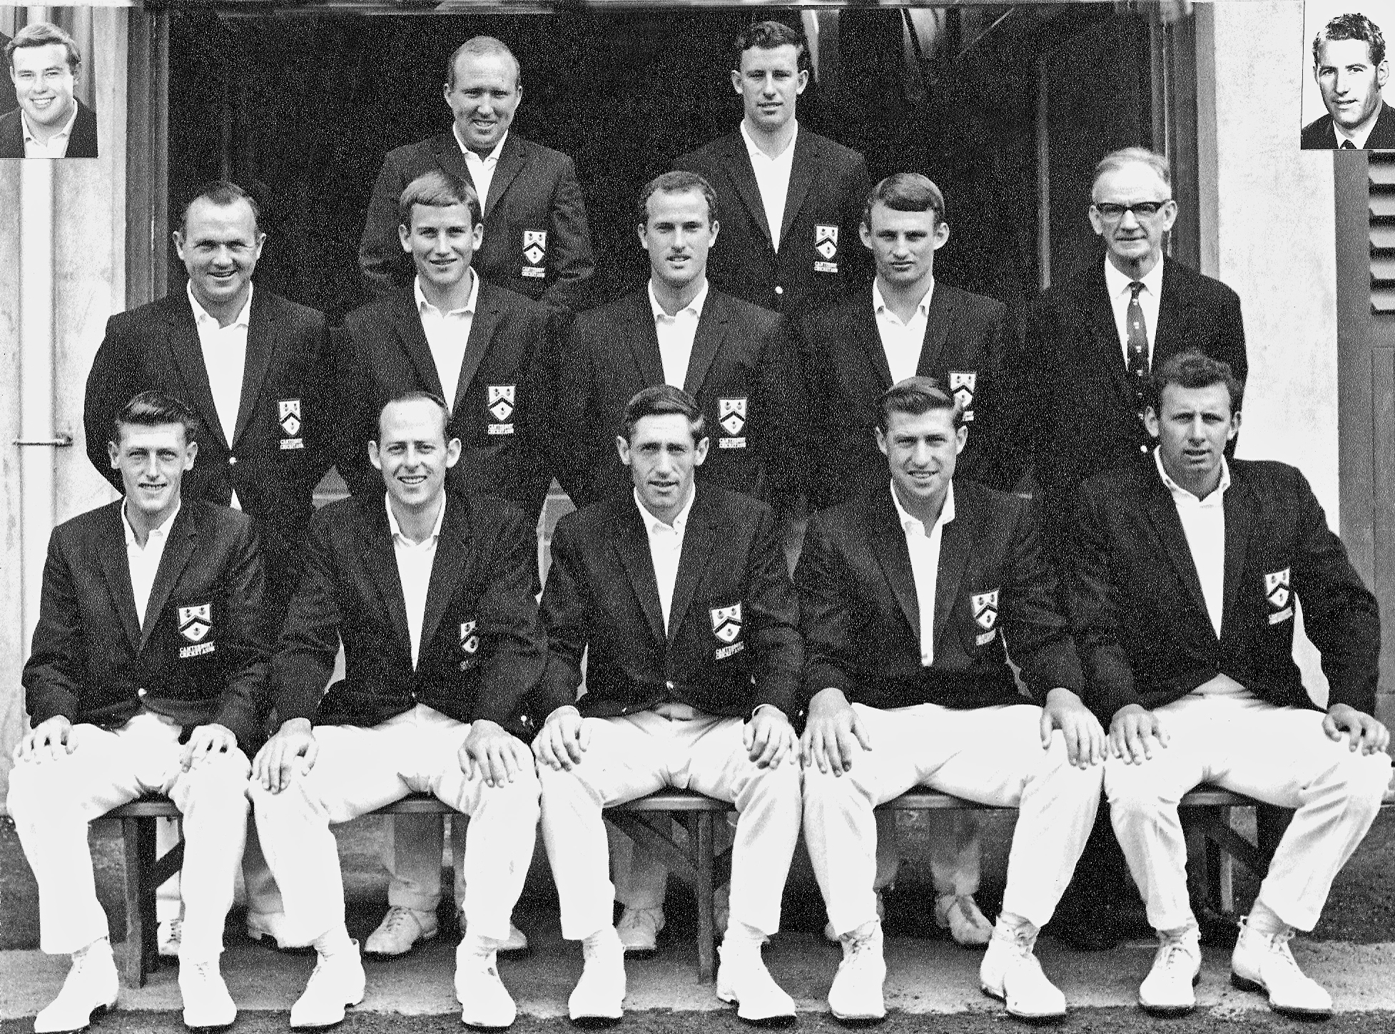

**Canterbury Representative Team 1968/69**

**Back row:** NA Huxford, JW Burtt

**Middle row:** K Thomson, JD Riley, JM McIntyre, CL Bull, CGF Hamilton (President)

**Front row:** JT Ward, BF Hastings, GT Dowling captain, RC Motz, BR Taylor

**Inset:** RW Anderson, PG Coman